The Old South

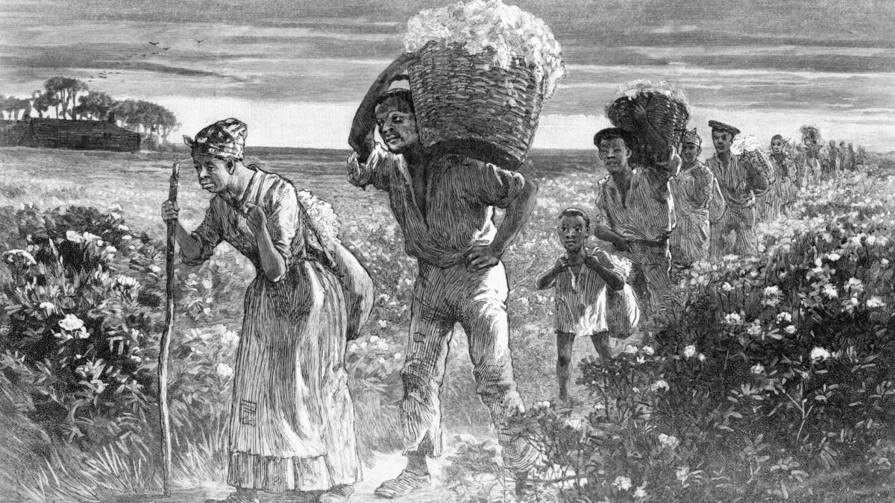

The Framers of the US Constitution made it a point to protect regional identity and political sovereignty. Before the Revolution, the colonies were semi-independent and loosely bound to one another. Each colony had its own identity, culture, economy and collective ideals. Some argued that the larger states such as Virginian would dominate the discussion regarding the course of the nation. Others feared that the morals and attitudes of some states would be thrust upon them. In a sense, this notion continued even to this day.

When the United States became a nation, the architects of the government sought to maintain regional identities through Federalism. The US is a Republic and a Republic is a nation consisting of a series of governments. Every town, county, city and state have a government with a jurisdiction and the entire nation is governed by the Federal Government.

Americans are very local creatures who tend to take pride in their respective regions. New Yorkers are proud to be from New York and Alabamans are proud to be from Alabama. New York has certain laws, values and ways of doing things, Alabama also has specific laws, values and ways of doing things. With this pride is an underlying sense of animosity to other regions. The most apparent historic regional issue was slavery. Some argued that slavery should be a state-issue and if a state wants to continue the practice that is up them. Others argued it was an abomination and should abolished altogether.

The slave-owning states, more or less countered with, “See, that is one state forcing it’s ideals on another state. If you do not like slavery, you are well within your right as a state to abolish it in your state. We are not forcing slavery on you; you should not force abolition on us.”

Were they right?

“The Old South” was a block of southern, slave-owning states (The Carolina’s Georgia, Alabama, Mississippi, Louisiana) who shared similar cultural traditions and values. The customs of the Old South were holdovers form the Old World and bloodlines and aristocratic appearance and manner reflected social rank. In the Old South it was important for the upper-class to appear dignified, well-dressed, proper and it was imperative to demonstrate such social standing. In other words, humility was not a value of the Old South and the well-to-do made sure to tell the world in many ways that they were well-to-do.

Slaves were not only forced human labor, but instruments to display status. Plantations in the south often purchased many slaves simply to demonstrate their wealth. Slave Houses were commonly built along the front of the plantation line so passers by could see the many slaves the plantation owner owned (See Plantation Layout on Page 301).

Slaves were not treated the same from region to region, planation to plantation and duty to duty. Some slaves, most, were laborers who toiled in fields to pick cotton, corn, rice, tobacco or sugar (which was particularly difficult work). Others were house slaves who prepared meals, kept the manor house, which were usually impressive mansions, laundry and other household tasks. Others still attended to the children. Horrifically, some were assigned yet more inhumane and degrading tasks that we may be better served to not mention.

Those who argued to protect the Peculiar Institution of Slavery made the points that slaves were given homes, were well-fed, treated when they were ill or injured and not worked to the point of exhaustion. They were typically given a day or two to rest each week. Sunday worship services were provided, and punishments were mostly, though not always, moderate. Southern lawmakers contended that slaves were incredibly expensive and slave masters would certainly not abuse their valued assets. Conversely, they claimed, in the north, industrial workers were treated unbelievably badly. They were not taken care of when they were sick, they were paid a pittance to work dangerous and laborious jobs and when they went hungry, nobody took care of them.

Task I: (two points each) For this week, you are in the instructor and I am the student. Your job is to create five questions based on Chapter 13: The Old South and Slavery. You do not need to answer your questions, but the questions must be high order thinking questions. In other words, this is not Jeopardy and you should not answer simple fact-based questions. For example: “What year did slave revolts in Haiti begin?”- that is not a good, thought-provoking question because anyone can easily answer it by writing “1804” and not show any understanding of the slave revolts.

Good questions usually begin with “why” or “how.” Remember the point is to get the student (me) to show that they understand and can explain informed critical thoughts.

Task II (two points each): Do the same based on the video Slaves Talk about Slaves in the USA. Create two thought-provoking questions. The only change from Task I is in this part, you must reference John Locke the Cotton Gin or Emancipation in each of your questions (you can’t use the same reference in more than one question).
https://www.youtube.com/watch?v=fZfcc21c6Uo

For either task, don’t be afraid to ask controversial questions, the goal is to think and explore the topic.
This is Due Sunday July 25th at 11:59 PM

